

STATEMENT OF ADVICE

Financial Planning Strategy

Prepared for:
Tim Holder and Georgina Holder
Of
49 Cutty Sark Road

CORONET BAY VIC 3984

Mobile: 0439 004 813

Email: tim.holder@fultonhogan.com.au

Prepared on:

30th March 2012

By your Adviser:

Andrew Lord B Bus (Acc), Dip FS (Fin Plan)

Lakeside Financial

Level 1, 99 Bay Street
Brighton VIC 3186

Ph: 03 9596 5111 Fax: 03 9596 3222

Email: Andrew.Lord@lakesidefinancial.com.au

Authorised Representative # 324798 Credit Representative #376361 of:
Guardianfp Ltd trading as Guardian Financial Planning
ABN 40 003 677 334 Australian Financial Services Licensee No. 237641
Level 10, 321 Kent Street, Sydney, NSW, 2000
Phone: 1300 720 350 Fax: 02 8275 3232 E-mail: enquiries@guardianfp.com.au
What this document is about
This Statement of Advice (or SoA) is an important document.
- It provides you with information about our advice so you can make a decision about implementing the advice.
- It should be read in conjunction with other documents such as Product Disclosure Statements and our Financial Services Guide.

What to do after reading this Statement of Advice
Please contact us.
- If you have any questions.
- If we have omitted, overlooked or incorrectly understood any of your relevant circumstances.
- When you are ready to implement the recommendations.
- Or, if you decide you want to do something else and need our advice or assistance.

30th March 2012

Mr Tim Holder and Mrs Georgina Holder
49 Cutty Sark Road

CORONET BAY VIC 3984

Dear Tim and Georgina,

I am pleased to enclose your Statement of Advice (SoA).

It is an important document that you should read and understand before making a decision to proceed further.

We have based the strategies and recommendations in this document on our understanding of your current personal and financial position. If any of this information does not reflect any part of your current position, goals and objectives please advise us immediately and we will make the necessary changes.

The SoA sets out our recommended strategies to address your needs, together with a recommended course of action to implement these strategies.

When you are ready to proceed, we would be very happy to help you with the implementation of the advice, including the completion and lodgement of application forms and other documents.

Please note, our recommendations in this Statement of Advice are valid for 30 days from the date on the cover of this document. If your circumstances change before you implement our recommendations, or if you don’t act on them within 30 days, they may no longer be appropriate for you. If that happens, please ask us to review your situation again before you take any action.

Once implemented, we should review your situation on a regular basis to ensure we make the most of any changes that may impact on the strategies I have recommended for you.

Yours sincerely,

Andrew Lord

B Bus (Acc), Dip FS (Fin Plan)
Authorised Representative No 324798 of
Guardianfp Ltd trading as Guardian Financial Planning
Table of Contents
STATEMENT OF ADVICE 1
Financial Planning Strategy 1
Purpose of this document 4
Timeframe for our advice 4
Check for accuracy 4
Limitations of our advice 4
Thank you for choosing Guardian Financial Planning 5
Product selection 5
Introduction 6
The Scope of Our Advice 6
Our Investment Recommendations 6
Your Adviser 7
The Planning Process 7
Executive Summary 8
Your Goals and Objectives 8
Recommendation Overview 8
Anticipated Outcomes 9
Future Strategies 9
Personal Information 10
Personal Details 10
Health Details 10
Employment Details 10
Estate Planning 10
Assets and Liabilities 11
Your Investor Risk Profile 12
Current Risk Management Policies 14
Retirement Planning 15
Strategy Recommendation 16
Replacement of an Existing Product - Tim 17
Replacement of an Existing Product - Georgina 18
Salary Sacrifice to Superannuation 20
The Government Co-contribution 22
Superannuation Contribution Limits 23
Your Finances 24
Investment Recommendations 25
Current Portfolio 25
Proposed Portfolio 26
Projected Superannuation Portfolio Profile Compared to Benchmark (Tim) 28
Projected Superannuation Portfolio Profile Compared to Benchmark (Georgina) 29
Estate Planning 32
Wills and Testamentary Trusts 32
Non Estate Assets 33
Powers of Attorney 34
What is paid to your adviser 35
Plan Fee 35
Upfront and Ongoing Fee Disclosure 35
Disclosure Statement 36
Summary 39
Appendix – Assumptions 41
Authority to Proceed 42

Purpose of this document

The following Statement of Advice (SoA) is an outline of the financial plan discussed with your financial planner. It details the recommendations needed to execute your plan and achieve your financial objectives.

Timeframe for our advice

Our recommendations in this SoA are valid for 30 days from the preparation date on the cover of this document. If your circumstances change before you implement our recommendations, or if you don’t act on them within 30 days, they may no longer be appropriate for you. If that happens, please ask us to review your situation before taking any action.

Check for accuracy

This SoA is based on the information you provided. Please read the document carefully, checking that your details are correct and that no important facts are missing. If anything is wrong or missing, please let us know immediately—otherwise our advice may be based on incorrect information and may not be right for you.

Limitations of our advice

We cannot give advice on:
- Trust or business structures | - Direct share or property purchases
- Taxation | - Legal matters
- General insurance

Please don’t consider any of this document’s recommendations to be advice in any of these areas. If you need advice in these areas, please see a qualified professional in that field.
Assumptions we've made

When giving advice, we make certain assumptions to demonstrate how the advice could affect your financial situation. We've based our advice on economic information and legislation that was current when we prepared your SoA.

All dollar amounts in this SoA are in today’s dollars, even when we mention future income, expenses, investment amounts and so on. Naturally we can’t predict what future inflation rates will be, so we can only make assumptions based on past trends. Also, all amounts listed in this document are “p.a.” (per annum) unless otherwise stated or implied.

Thank you for choosing Guardian Financial Planning
Guardian Financial Planning is owned by Asteron Limited ABN 94 000 015 949 and is part of the Asteron group of companies which comprises: Asteron Portfolio Services Limited, Asteron Life Limited, Tyndall Investment Management Limited, Tyndall Asset Management Limited, Asteron Advisory Services Limited, Standard Pacific Consulting Limited and Standard Pacific Accounting Ltd. The Asteron Group of companies is ultimately owned by Suncorp-Metway Limited ABN 66 010 831 722 (“Suncorp”). Suncorp is listed on the Australian Stock Exchange. The different entities of the Suncorp Group are not responsible for or liable in respect of products or services provided by other entities of the Suncorp Group.

Some of the products and services we may deal in and advise on your behalf are provided by other Suncorp companies. These companies are listed in the section headed ‘Who owns Guardian Financial Planning’ in the copy of the Financial Services Guide we gave you. This document also outlines who your Authorised Representative is and their contact details in the section headed ‘Before you get advice – Who is my adviser?’ Please ask if you’d like another copy free of charge.

Product selection

We are committed to giving you the best products for your situation. When preparing your advice we considered and recommended only those products on Guardian Financial Planning’s “Approved Product List”. This list was compiled by a dedicated Investment Review Committee, which regularly reviews it. To see the complete product list, please ask us.

Introduction

You are entitled to receive a Statement of Advice (SoA) whenever we provide you with any personal financial advice. Personal financial advice is advice that takes into account any one or more of your objectives, financial situation and needs.

This SoA is a record of the personal financial advice provided to you and includes information on the basis on which this advice is given, information about remuneration including fees, commissions, any other benefits and any interests, relationships or associations which might influence the making of the advice.

If this advice includes a recommendation to you to acquire a particular financial product (other than securities) or an offer to issue or arrange the issue of a financial product to you, we will also provide you with a Product Disclosure Statement containing information about the particular product to help you make an informed decision about that product.

The Scope of Our Advice

In this statement of advice, the main focus is on:

- Superannuation
- Retirement Planning
- Finance Structure
- Estate Planning

This advice is based on information we have obtained from you. You must ensure the information is accurate and complete. Otherwise, this advice may be based on inaccurate or incomplete information relating to your investment objectives, financial situation or needs. You must therefore assess whether the advice is appropriate, in the light of your own individual investment objectives, financial situation or needs.

You recognise in each of the areas of advice we provide, we only provide advice to the extent we are able to under the relevant legislation.

Our Investment Recommendations

In respect of the specific investments we recommend as part of our advice you are entitled to a 14 day cooling off period for your initial investment. A cooling off period generally means a period of time after which you have provided your capital for investment, where you can change your mind and request for your capital to be returned to you.

Each fund manager or investment provider may implement the cooling off period in a slightly different manner. Therefore we recommend you refer to the Product Disclosure Statement for each of the recommended investments in order to understand the operation of each provider’s cooling off period.

Your Adviser

At any time should you have any questions or concerns, in the first instance please contact your adviser Andrew Lord on (03) 9596 5111.

Andrew Lord is authorised to represent Guardianfp Limited. Should you wish to discuss matters of concern about your adviser or the advice you have received please contact our Compliance Officer on 1800 687 620.

The Planning Process

Tim and Georgina, Financial Planning is a process to help you reach both your Personal and Financial Goals and Objectives. In order to achieve this we jointly need to undertake a number of tasks, including:

- Confirm your personal goals and lifestyle objectives;
- Quantify the resources required to meet your goals and objectives;
- Identify any gaps in your current plans and your stated goals and objectives;
- Develop suitable strategies to address any differences that may exist bearing in mind your attitude to investing and your risk profile;
- Conduct a regular review of the strategies we put into effect to ensure they keep pace with your changing needs, legislative changes and the investment environment.

Executive Summary

In this plan our advice considers the following areas of your financial circumstances.

Your Goals and Objectives

After our discussions I have listed below what we agreed were your key goals and objectives. The points listed below form the basis of the plan I have prepared, and therefore you should read them carefully now to ensure that we have an accurate foundation on which to proceed. If there are any modifications required, please advise us prior to the commencement of your financial plan.

Your goals and objectives are to:

- Review and consolidate your existing portfolios within superannuation.
- Review your superannuation contribution strategies with the aim of increasing your retirement savings in a tax effective manner.
- Minimise your tax commitments.
- Ensure you have appropriate lending arrangements in place and to have these structured in the most tax effective manner.
- Ensure you have appropriate estate planning strategies in place.

Recommendation Overview
Considering your stated goals and objectives, investor risk profile and age we recommend that:

- Tim, rollover your existing Asteron, Vision and Supertrace superannuation funds into the recommended wholesale platform with a Balanced portfolio.
- Georgina, rollover your existing Hesta superannuation fund into the recommended wholesale platform with a Moderately Conservative portfolio.
- Tim, salary sacrifice $7,000 per annum ($2,333 per month for the remainder of this financial year and $583 per month in the 2012/13 financial year) to the recommended superannuation platform.
- Georgina, take advantage of the Government Co-contribution and make a non-concessional contribution of $1,000 to the recommended superannuation platform.
- Review your estate planning needs in order to ensure that your estate is distributed to your beneficiaries in a correct and tax effective manner.

Anticipated Outcomes
Following our recommendations, we anticipate that:

- Tim, your income tax liability we estimate will be reduced by $2,205 PER ANNUM.
- Tim, your capital is invested inside of the superannuation environment consistent with your Balanced investor risk profile.
- Georgina, your capital is invested inside of the superannuation environment consistent with your Moderately Conservative investor risk profile.
- Georgina, you should be entitled to the government co-contribution benefit of $1,000 in this financial year. In future financial years this should not change, provided the co-contribution is still offered and your circumstances do not change dramatically.
- You have tax effective Wills that include Testamentary Trusts and appropriate Powers of Attorney.

Future Strategies

- To annually review superannuation contributions and investment performance.

Personal Information

During our discussions and from the information you have provided, your Personal Details can be summarised as follows:

Personal Details
Title | Mr | Mrs
First Name | Tim | Georgina
Surname | Holder | Holder
Gender | M | F
Date of Birth | 4/01/1967 | 17/12/1966
Age Last Birthday | 45 | 45
Marital Status | Married | Married

Health Details
Health Status | Good | Good
Smoking Status | No | No

Employment Details
Employment Status | Full Time | Part Time
Occupation | Divisional Manager – Civil Engineering | Registered Nurse
Employer | Fulton Hogan | Cabrini Hospital
Proposed Retirement Age | 65 | 60

Estate Planning
 |  | Tim |  | Georgina
Do you have a Current Will? |  | Yes |  | Yes
Date Last Reviewed |  | 2002 |  | 2002
Do you have Current Powers of Attorney? |  | No |  | No
Do you have a Testamentary Trust? |  | No |  | No

Assets and Liabilities
The following is an Asset and Liabilities summary that estimates your Net Worth position based on the information provided.
ASSETS
Lifestyle Assets | Value
Residential Home | $460,000
Holiday House | $300,000
Home Contents | $130,000
Motor Vehicles | $20,000
Total Lifestyle Assets | $910,000

Investment Assets
Investment Property | $1,100,000
Cash | $5,000
Total Investment Assets | $1,105,000

Superannuation Assets
Tim  Australian Super  Vision Super  Supertrace (a/c # 01167950)  Supertrace (a/c # 01125049) | $50,510  $41,661  $236  $61  $92,468
Georgina  Hesta | $71,213
Total Superannuation Assets | $163,651

Total ASSETS | $2,178,651

LIABILITIES
Investment Loans
Investment Property | $540,000
Residential Property | $483,000
Total Personal Loans | $1,023,000

NET WORTH | $1,155,651

Notes: As the above information has been used in preparing our recommendations please advise us of any errors or omissions.

The ‘Total’ column indicates the value of assets and liabilities which are owned by you. This report does not show the value of any portion of the asset or liability that may be owned by a third party or associated entity.

Your Investor Risk Profile

The following section of your plan helps to ensure that I clearly understand your attitude to investment selection. Additionally, investments contain various characteristics, which may or may not suit each individual investor.

Based upon your responses to the Risk Profile Questionnaire, it was determined Tim has a Balanced investor risk profile and Georgina has a Moderately Conservative risk profile.

Typically, a Balanced investor has the following characteristics:

- The Balanced investor will typically operate a portfolio evenly split between interest bearing securities and growth oriented investments.
- An exposure to a range of investment sectors including cash, fixed interest, property and shares ensures the portfolio is “truly” balanced.
- Investors are typically comfortable with a variability of their capital over a 5 year horizon while their portfolio builds a growing income stream and capital growth.

A Balanced investor will typically diversify their investment in the following manner:

Australian Shares 34%
International Shares 20%
Fixed Interest 26%
Property 14%
Cash 6%

Typically, a Moderately Conservative investor has the following characteristics:

- The Moderately Conservative investor seeks a diversified portfolio with a balance of defensive and growth assets.
- This requires an investment time horizon of between 3 – 5 years.
- The portfolio would be include a high portion of income bearing securities such as cash and fixed interest, with a small exposure to equities and property providing appreciation potential.

A Moderately Conservative investor will typically diversify their investment in the following manner:

Australian Shares 24%
International Shares 14%
Fixed Interest 38%
Property 10%
Cash 14%

Our research indicates that long term returns will be best achieved through a diversified portfolio covering all major asset classes (i.e. Cash, Fixed Interest, Shares and Property).

By covering all primary investment markets the risks and volatility of your investments can be managed to levels consistent with your investment profile, whilst maintaining the potential for long term growth.

If you feel the above investor profiles do not reflect your attitude as an investor, or the recommended portfolio contained in this report is too aggressive or conservative, please let me know so I may adjust my recommendations accordingly.

Our recommendation has been made given your risk tolerance, while in balance with your goals and objectives.

Our recommendation has been made given your risk tolerance, while in balance with your goals and objectives.

Current Risk Management Policies

Life Insured: Mr Tim Holder
Product: Underwriter | Policy Owner | Death | TPD | Trauma | Income Protection  Per month | Annual Premium
AIA | Super | $1,500,000 | - | - |  | $1,278
AIA | Tim | - | - | $200,000 | $12,250* | $2,752
Total Sums Insured |  | $1,500,000 | $0 | $200,000 | $12,250 | $4,030

* Cover paid to age 65 against illness and injury after a 90 day waiting period.

Note: These insurances are in the process of being put in place via your Risk Adviser Andrew Edwards.

Life Insured: Mrs Georgina Holder
Product: Underwriter | Policy Owner | Death | TPD |  | Trauma | Income Protection  Per month | Annual Premium
Asteron | Georgina | $1,370,719 | - |  | - | - | $1,608
Total Sums Insured |  | $1,370,719 |  | $0 | $0 | $0 | $1,608

Retirement Planning

You have stated you wish to retire at age 65.

As you have not provided us with a required retirement income amount, we have based our projections on the industry general rule of thumb, that you will require approximately 75% of your combined current net salary ($118,000) in retirement. That being $59,000 pa each.

Recommendations:

- To achieve a retirement income of $118,000 per annum we estimate you will need the following capital amount:
  - Tim will need around $734,462 in initial retirement capital at age 65 to generate an income of $59,000 p.a.
  - Georgina will need around $806,316 in initial retirement capital at age 65 to generate an income of $59,000p.a.
- We estimate that by the time:
  - Tim is age 65 he will have a conservatively estimated accumulated retirement capital balance of around $566,707.
  - Georgina is age 60 she will have a conservatively estimated accumulated retirement capital balance of around $221,396.
- Based on these figures you currently have a retirement capital shortfall of an estimated $752,675.
- You will need to consider additional wealth accumulation strategies such as salary sacrifice to help you achieve your capital goal. We will provide ongoing advice to help you achieve this.

Risks:

- Superannuation benefits are subject to market returns and earning rates are not guaranteed.

Strategy Recommendation
Superannuation Funds

Recommendations:

- Tim, rollover your existing Australian Super, Vision Super and Supertrace funds to the recommended wholesale superannuation fund platform. (See Colonial FirstChoice investment section on page 30.)
- Georgina, rollover your existing Hesta Super fund to the recommended wholesale superannuation fund platform. (See Colonial FirstChoice investment section on page 30.)
- Tim and Georgina’s portfolios are to be invested according to a sector specific asset allocation that is in line with your respective investor risk profiles.
- All future contributions are to be directed to the recommended superannuation fund.

Benefits:
- A sector specific asset allocation strategy takes advantage of expert fund managers who specialise in that single sector.
- You will have access to an anti-detriment payment. This is where the contributions tax you pay on monies contributed may be refunded on the death of a member.
- You will have access to a wide range of investment options with access to more than one specialist manager within each asset class.
- The recommended fund platform has a wide range of investment options with access to more than one specialist manager within each asset class.
- Your benefits will be invested within a range of assets and asset classes giving you a well diversified investment portfolio that aims to generate higher levels of growth over the longer term 7+ years.
- You will gain ongoing advice from us as your financial adviser as we will have full access to information relating to the recommended superannuation fund. This will enable us to provide thorough and timely advice to you.
- Lakeside Consultants can arrange for your life insurance premiums to be deducted from your superannuation account, which is a more tax effective way of paying them.
Risks:
- The recommended investment’s performance is subject to market fluctuations.
- Investment performance is not guaranteed.

Replacement of an Existing Product - Tim
Type of Fee or Cost | Australian Super | Vision Super | Supertrace | Colonial WS Super Fund
Contribution/Entry fee – this is the fee for initial and subsequent contributions. | Nil | Nil | Nil | Nil
Withdrawal/Exit Fee – this is the fee for each withdrawal you make | $35 | Nil | Nil | Nil
Switching Fee – fee charged for switching between investment options in the super fund. | Nil | Nil | Nil | Nil
Administration Costs – are the fees and costs that cover the operation of the fund. They include admin, member and other fees charged by the product issuer | 0.03% + $78 p.a. | $91 p.a. | Nil | Nil
Adviser Service Fee – additional fee paid to financial adviser | Nil | Nil | Nil | 0.75% p.a
Investment Costs - Current – are the fees and costs the product issuer charge for investing the assets. These include fees paid to external fund mgrs. | 0.59% p.a. | 0.47% p.a. | 1.55% p.a. | 1.02% p.a
Annual average cost - Total $92,468 investment | $651 | $526 | $1,433 | $1,636
Investment Costs –  Relevant to Your Risk Profile | Same as above | Same as above | Same as above | Same as above
Annual average cost – Relevant to Your Risk Profile $92,468 | Same as above | Same as above | Same as above | Same as above
Amount of Insurance Cover – Life, TPD and Income Protection held inside super | $78,600 Death/TPD  $3,000 p.m. IP | $39,700 Death/TPD  $3,500 p.m. IP | n/a | n/a
Cost of above insurance cover per annum. | $306.28 | $313.56 | n/a | n/a

The investment cost will vary depending on which fund you are invested in, the assets it invests into and how actively they manage their portfolios, amongst other things. Typically these costs should not be compared directly.

Replacement of an Existing Product - Georgina
Type of Fee or Cost | Hesta | Colonial Wholesale Super Fund
Contribution/Entry fee – this is the fee for initial and subsequent contributions. | Nil | Nil
Withdrawal/Exit Fee – this is the fee for each withdrawal you make | Nil | Nil
Switching Fee – fee charged for switching between investment options in the super fund. | Nil | Nil
Administration Costs – are the fees and costs that cover the operation of the fund. They include admin, member and other fees charged by the product issuer | $65 p.a. | Nil
Adviser Service Fee – additional fee paid to financial adviser | Nil | 0.75% p.a
Investment Costs - Current – are the fees and costs the product issuer charge for investing the assets. These include fees paid to external fund mgrs. | 0.81% p.a | 0.88% p.a
Annual average cost - Total $71,213 investment | $577 p.a. | $1,160
Investment Costs –  Relevant to Your Risk Profile | Same as above | Same as above
Annual average cost – Relevant to Your Risk Profile $71,213 | Same as above | Same as above
Amount of Insurance Cover – Life, TPD and Income Protection held inside super | n/a | n/a
Cost of above insurance cover per annum. | n/a | n/a

The investment cost will vary depending on which fund you are invested in, the assets it invests into and how actively they manage their portfolios, amongst other things. Typically these costs should not be compared directly.

Outcomes Post Recommendation:

- You will gain access to a diversified portfolio of funds that matches your investor risk profile and investment objectives. On our analysis this should position you for better long term returns.

Salary Sacrifice to Superannuation

- Tim, you are currently not Salary Sacrificing.

Recommendation:

- Tim, consider commencing a Salary Sacrifice arrangement of $7,000 per annum into the recommended superannuation fund. This is to be structured as follows;
Remaining 3 months of the 2011/12 financial year:
Salary sacrifice $2,333 per month
For the 2012/123 financial year:
Salary sacrifice $583 per month
As you are currently receiving employer super contributions of $17,640 p.a., this additional salary sacrifice of $7,000 p.a. will bring you up to the $25,000 maximum concessional contribution limit.
- Arrange this with your employer as soon as possible.

Benefits:

- By salary sacrificing, you are building your superannuation benefits at an increased level, resulting in achieving your retirement capital goals sooner.
- The main purpose behind this strategy is to start building Tim’s super balance at an increased rate in an effort to achieve your required retirement income.
- Tim, you will also receive a reduction in Taxable Income for the contributions that you make
- Superannuation contributions are concessionally taxed at a maximum of 15% as opposed to your current marginal tax rate of 46.5%.
- The total tax saving amounts to $2,205 p.a.
- Tim, we estimated that by the time you are 65 you would have a conservatively estimated accumulated retirement capital balance of around $566,707. By implementing the additional $7,000 per annum salary sacrifice we estimate that your accumulated retirement capital would be in the vicinity of $745,025, which is an increase of $178,318 when you reach retirement at age 65. Therefore, we anticipate you will be significantly closer to achieving your retirement income goal.

Risks:

- All superannuation contributions are considered preserved benefits until a condition of release is satisfied, and only then may your superannuation benefits be accessed.
- Superannuation benefits are subject to market returns and earning rates are not guaranteed.

IMPORTANT: It is important that any salary sacrifice arrangement is clearly documented in writing. You should also confirm with your employer that they are going to continue to pay Superannuation Guarantee Contributions (SGC) on the grossed up amount of your package, i.e. that the SGC will continue to be calculated on the total of your salary + salary sacrificed amount. Following the implementation of the strategy and investment recommendations within this report, we estimate that your future tax liabilities and cash flow to be as follows.

The Government Co-contribution

The Government Co-contribution scheme was introduced to encourage low-to-middle income earners to save for their retirement. Under this scheme the government will pay contributions to superannuation for individuals who meet certain criteria (See General information on superannuation Appendix for specific eligibility criteria).

If a person earns less than $31,920 per annum, personal contributions will be matched by the government with $1 for every $1 contributed up to a maximum of $1,000. If a person earns between $31,920 per annum and $61,920 per annum, they will be entitled to a reduced co-contribution amount.

The Government co-contribution scheme has been extended to include self-employed persons who are less than 71 at the end of the income year, not a temporary resident, earn 10% or more of their total income from running a business in the relevant year.

From 1 July 2009, salary sacrifice contributions will be included as part of your total income when assessing your eligibility for the co-contribution.

Note: Any personal contributions that you choose to claim as a tax deduction will not qualify for co-contribution purposes.

Recommendation:

- Georgina, as you are currently earning $30,000 per annum, make a non-concessional contribution to your superannuation of $1,000 this financial year.

Benefits:

- Based on your current income, you will be eligible for a government co-contribution benefit of $1,000.
- By applying for the co-contribution you are effectively having the government help you to save for your retirement.
- The maximum benefit is in effect a 100% return on your investment.

Risks:

- All superannuation contributions are considered preserved benefits until a condition of release is satisfied, and only then may your superannuation benefits be accessed.
- Superannuation benefits are subject to market returns and earning rates are not guaranteed.
- Earnings expectation may not be achieved.

Superannuation Contribution Limits

Table 1- Concessional contribution limits

Concessional contributions include employer and self employed contributions such as salary sacrifice, superannuation guarantee and personal concessional contributions.

Date | Limit (per annum)
Date | Age 35-49 | Age 50 to 64 | Age 65 to 74* | Age75 and over
From 1 July 2009 | $25,000 | $50,000 | $50,000 | Cannot contribute
From 1 July 2012**  (super balance > $500k) | $25,000 | $25,000 | $25,000 | Cannot contribute
From 1 July 2012**  (super balance < $500k) | $25,000 | $50,000 | $50,000 | Cannot contribute

*Must be employed at least 40 hours during any consecutive 30 day period in the financial year you would like to make the contributions.
Concessional Contributions were previously known as Deductible Contributions (e.g. Salary Sacrifice).

** Subject to legislation being passed.
$50,000 $50,000 $50,000 $25,000/$50,000 $25,000/$50,000

$25,000 $25,000 $25,000 $25,000 $25,000

1/7/09 1/7/10 1/7/11 1/7/12 1/7/13 1/7/14

Under age 50
Aged 50 to 75

Table 2 - Non-concessional contribution limits

Date | Limit on after-tax contributions | Eligibility Requirements
Date | Limit on after-tax contributions | Under age 65 | Age 65 to 74 | Age 75 and over
From  1 July 2007 | $150,000 p.a. | May bring forward two years of contributions to make a $450,000 contribution in one financial year | Must be employed* | Can not contribute
$150,000 $150,000 $150,000 $150,000 $150,000

1/7/07 1/7/08 1/7/09 1/7/10 1/7/11 1/7/12

If over age 65 then must be employed
$450,000 over rolling 3 year period

Your Finances

Tim and Georgina, you have converted your previous residential property in East Malvern into an investment property. This property is valued at approximately $1,100,000 and has an outstanding debt of approximately $540,000. You are currently paying principal and interest repayments on this debt. Furthermore, you have recently purchased a new residential property in Blairgowrie for $460,000. You made the decision to set up your lending arrangements directly with Police Credit Co-Op.

Recommendation:

- Restructure the debt against your investment property in a manner that allows for interest only repayments.
- As part of the refinancing process, transfer this property into Georgina’s name only as it is positively geared and Georgina is the lower income earner.
- Set up an appropriate lending structure for your Blairgowrie property.

Investment Recommendations

After considering your investment profile, your financial objectives, the current economy and economic trends, we recommend that your funds be invested in the following manner.

Current Portfolio
ASSETS
Lifestyle Assets | Value
Residential Home | $460,000
Holiday House | $300,000
Home Contents | $130,000
Motor Vehicles | $20,000
Total Lifestyle Assets | $910,000

Investment Assets
Investment Property | $1,100,000
Cash | $5,000
Total Investment Assets | $1,105,000

Superannuation Assets
Tim  Australian Super  Vision Super  Supertrace (a/c # 01167950)  Supertrace (a/c # 01125049) | $50,510  $41,661  $236  $61  $92,468
Georgina  Hesta | $71,213
Total Superannuation Assets | $163,651

Total ASSETS | $2,178,651

LIABILITIES
Investment Loans
Investment Property | $540,000
Residential Property | $483,000
Total Personal Loans | $1,023,000

NET WORTH | $1,155,651

Proposed Portfolio
ASSETS
Lifestyle Assets | Value
Residential Home | $460,000
Holiday House | $300,000
Home Contents | $130,000
Motor Vehicles | $20,000
Total Lifestyle Assets | $910,000

Investment Assets
Investment Property | $1,100,000
Cash | $5,000
Total Investment Assets | $1,105,000

Superannuation Assets
Tim  Australian Super  Vision Super  Supertrace (a/c # 01167950)  Supertrace (a/c # 01125049)  Colonial FirstChoice Wholesale Super Fund | $0  $0  $0  $0
  BT Wholesale Core Australian Share
  Fidelity Wholesale Australian Equities
  Perennial Wholesale Value Australian Share
  Ausbil Wholesale Australian Emerging Leaders
  BT Core Wholesale Global Share Fund (AQR)
  Platinum Wholesale International
  Perpetual Wholesale International Share Fund
  MFS Wholesale Global Equity
  BT Wholesale Property Investment
  CFS Wholesale Global Listed Infrastructure Securities
  CFS WS Colliers Global Property Securities
  FirstChoice Wholesale Fixed Interest
  CFS Wholesale Cash Fund
  $9,247
  $9,247
  $9,247
  $4,623
  $4,623
  $4,623
  $4,623
  $4,623
  $4,623
  $4,623
  $4,623
  $22,192
  $5,548
 | $92,468

Georgina  Hesta  Colonial FirstChoice Wholesale Super Fund | $0
  BT Wholesale Core Australian Share
  Fidelity Wholesale Australian Equities
  Perennial Wholesale Value Australian Share
  BT Core Wholesale Global Share Fund (AQR)
  MFS Wholesale Global Equity
  BT Wholesale Property Investment
  CFS WS Colliers Global Property Securities
  FirstChoice Wholesale Fixed Interest
  CFS Wholesale Cash Fund
  $5,697
  $5,697
  $5,697
  $4,985
  $4,985
  $3,561
  $3,561
  $27,061
  $9,970
 | $71,213
Total Superannuation Assets | $163,651

Total ASSETS | $2,178,651

LIABILITIES
Investment Loans
Investment Property | $540,000
Residential Property | $483,000
Total Personal Loans | $1,023,000

NET WORTH | $1,155,651

Projected Superannuation Portfolio Profile Compared to Benchmark (Tim)

Asset Class | Projected Portfolio | Benchmark Profile for Balanced | Deviation
Australian Shares | 34% | 34% | 0%
International Shares | 20% | 20% | 0%
Property | 14% | 14% | 0%
Fixed Interest | 26% | 26% | 0%
Cash | 6% | 6% | 0%
Other | 0% | 0% | 0%

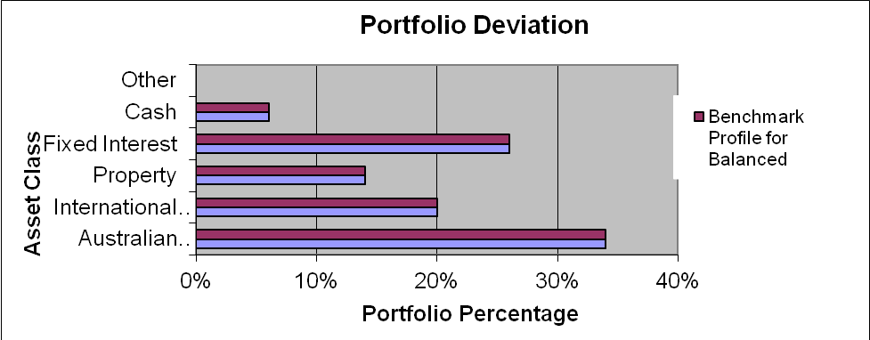

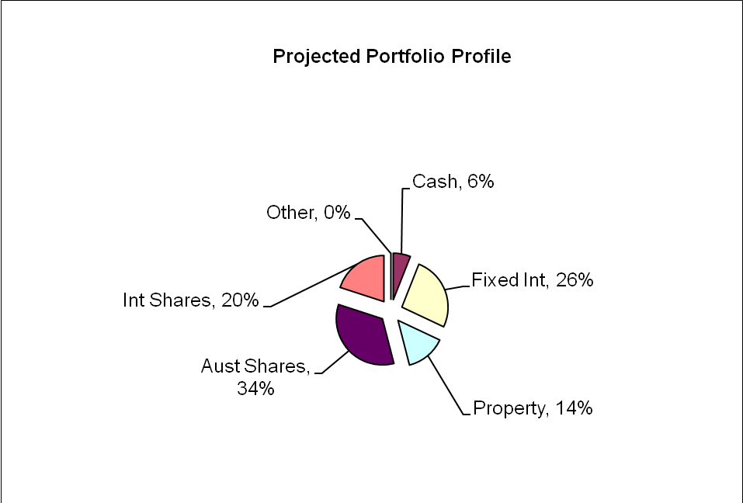

Projected Superannuation Portfolio Profile Compared to Benchmark (Georgina)

Asset Class | Projected Portfolio | Benchmark Profile for Moderately Conservative | Deviation
Australian Shares | 24% | 24% | 0%
International Shares | 14% | 14% | 0%
Property | 10% | 10% | 0%
Fixed Interest | 38% | 38% | 0%
Cash | 14% | 14% | 0%
Other | 0% | 0% | 0%

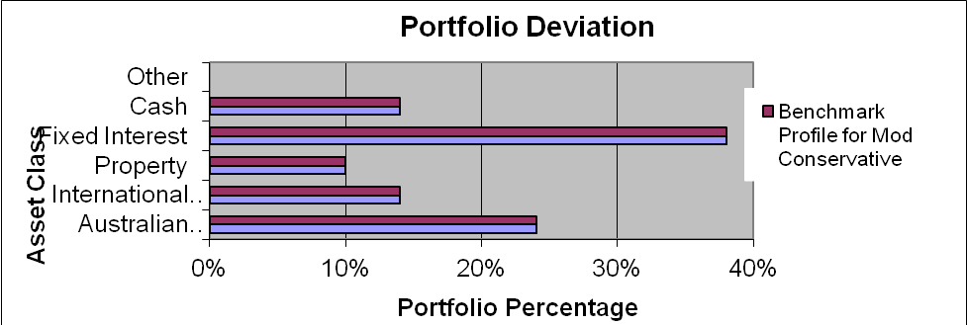

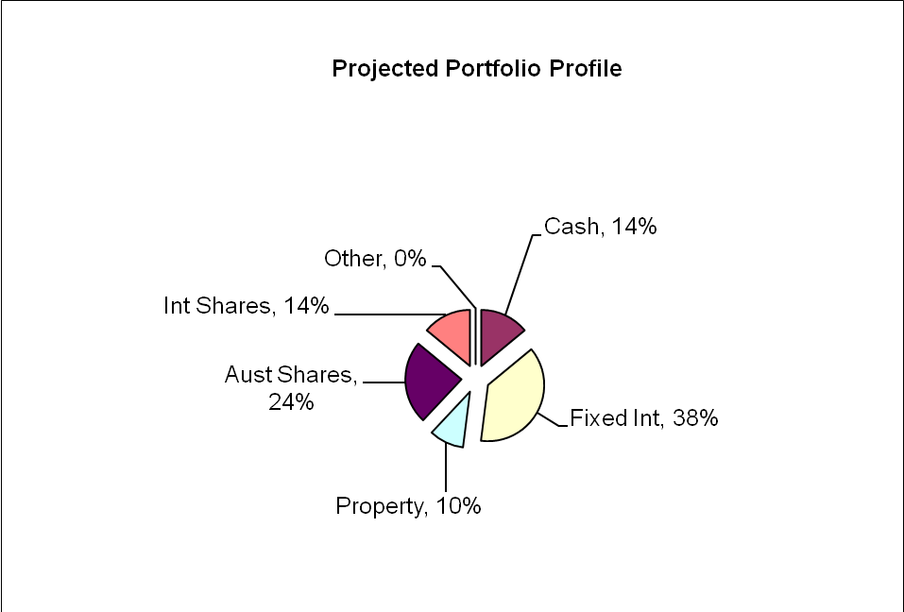

As an industry standard, a variance of 10% within a particular asset class is allowed to cater for individual circumstances, economic events and fund manager asset allocation decisions. Variations outside of this range may be appropriate in certain circumstances.
Colonial FirstChoice Wholesale Investments
The FirstChoice Wholesale Investments is a multi-manager investment solution which combines wide investment choice with a competitive and simple fee structure, backed up by a high standard of service support from Colonial First State.

The minimum initial investment the Colonial FirstChoice Wholesale Investments Plan accepts is $1000. There is no minimum additional investment amount required, however minimum regular investment and withdrawals are set at $500. Regular payments can also be made by BPay. You can then monitor and manage your investments over the Internet, by phone or through your financial adviser.

Reasons and Benefits
The major features of the Colonial FirstChoice Wholesale Investments are as follows:
Sector Specific Diversification
A strong range of investment options with access to more than one specialist manager within each asset class. This approach captures the competitive advantages of each manager. We anticipate this will provide higher returns than can be obtained from using diversified funds with, say, only one fund manager.

Simplicity
Consolidated reporting from Colonial First State.
Ease of Management
Automatic investment re-balancing and switching to help you easily and conveniently keep your investment strategies on track.
- We recommend that annual automatic rebalancing is elected.
Highly competitive and simple to understand fee structure
- No entry fee applies to this investment however, with your agreement; your Financial Adviser may wish to charge a one off fee to cover upfront costs.
- An ongoing management fee ranging from 0.31% p.a. to 2.96% p.a. applies, depending on investment options chosen. This fee is all inclusive, covering Colonial First State's administration fee and investment management fee. No ongoing remuneration is paid to Guardian Financial Planning out of this fee.
- The weighted average management fee for the Colonial FirstChoice Wholesale Investments Plan is 1.11% for Growth.
- You can agree with your Financial Adviser to have an ongoing Adviser Service Fee for advice paid directly from your investment. The ongoing fee will be deducted monthly from your investment options.
  - Our normal 0.75% p.a. Adviser Service fee will apply.
- No switching fees or exit fees apply to this investment.
- Within the Wholesale Investment plan a buy-sell spread of between 0 – 0.55% applies depending on investment option. Please refer to the Product Disclosure Statement for details.
Colonial FirstChoice Management Fee
Colonial FirstChoice charges a Management Expense Ratio to cover their administration costs and the associated costs of managing your funds and the advisers trail fee. Based on your current portfolio value, we have provided an estimation of the costs you will pay.

Tim  Colonial FirstState FirstChoice Investments | MER  % | Amount invested   $ |  | Estimated  fee  $
BT Wholesale Core Australian Share | 1.02% | $9,247 |  | $94
Fidelity Wholesale Australian Equities | 1.06% | $9,247 |  | $98
Perennial Wholesale Value Australian Share | 1.01% | $9,247 |  | $93
Ausbil Wholesale Australian Emerging Leaders | 1.01% | $4,623 |  | $47
BT Core Wholesale Global Share Fund (AQR) | 1.32% | $4,623 |  | $61
Platinum Wholesale International | 1.82% | $4,623 |  | $84
Perpetual Wholesale International Share Fund | 1.38% | $4,623 |  | $64
MFS Wholesale Global Equity | 1.22% | $4,623 |  | $56
BT Wholesale Property Investment | 1.05% | $4,623 |  | $49
CFS Wholesale Global Listed Infrastructure Securities | 1.25% | $4,623 |  | $58
CFS WS Colliers Global Property Securities | 1.02% | $4,623 |  | $47
FirstChoice Wholesale Fixed Interest | 0.77% | $22,192 |  | $171
CFS Wholesale Cash Fund | 0.40% | $5,548 |  | $22
Total ongoing fees | 1.02% | $92,468 |  | $944
Georgina  Colonial FirstState FirstChoice Investments | MER  % |  | Amount invested   $ | Estimated  fee  $
BT Wholesale Core Australian Share | 1.02% |  | $5,697 | $58
Fidelity Wholesale Australian Equities | 1.06% |  | $5,697 | $60
Perennial Wholesale Value Australian Share | 1.01% |  | $5,697 | $58
BT Core Wholesale Global Share Fund (AQR) | 1.32% |  | $4,985 | $66
MFS Wholesale Global Equity | 1.22% |  | $4,985 | $61
BT Wholesale Property Investment | 1.05% |  | $3,561 | $37
CFS WS Colliers Global Property Securities | 1.02% |  | $3,561 | $36
FirstChoice Wholesale Fixed Interest | 0.77% |  | $27,061 | $208
CFS Wholesale Cash Fund | 0.40% |  | $9,970 | $40
Total ongoing fees | 0.88% |  | $71,213 | $625
 Colonial FirstChoice’s Management Fee is calculated on the value of your total portfolio. As such we have used your current portfolio to estimate your annual ongoing fee.

Please note that there is an additional adviser service fee of 0.75% that is paid by you. Additional details of the above fees are outlined in the Colonial’s Product Disclosure Statement.

Estate Planning

Although considerable emphasis is placed on wealth creation and protection, a third vital aspect of your financial strategy is the control of the manner in which your wealth will be distributed after your death.

The expression “Estate planning” represents the concept of the planning and documentation of your wishes for the distribution of your wealth following death, whether the assets are held personally or controlled by related entities such as trusts or companies.

Estate planning is a specialised area, and it is important that you obtain professional advice in relation to all areas of your estate plan. However we outline below some of the issues you should consider in designing your estate plan.

Wills and Testamentary Trusts

A Will is the first step in ensuring that the distribution of your estate is actioned in accordance with your wishes. If you die without a Will (intestate), it may be that a court will control both the manner of distribution of your estate and the persons to whom your estate is distributed, and this can cause unnecessary distress.

You have a Will that was last reviewed over 10 years ago, but it does not have testamentary trust provisions.

Recommendation:

We have a relationship with Lakeside Legal Pty Ltd who are in the process of assisting you both with the implementation of an appropriate Will.
It is important to ensure your Wills:
  - Nominates executors (and substitute executors) who are likely to survive you and who clearly understand your wishes.
  - Nominates beneficiaries in relation to every segment of your estate and nominates alternative beneficiaries should your primary beneficiaries predecease you.
  - Bequeaths monetary value or a percentage of your estate rather than a specific asset, as there is the risk that an asset may not be in existence at the time of distribution of the estate.
  - Nominates assets to be held in trust for beneficiaries under 18 years of age. For example, you can provide funds for your children’s or grandchildren’s education.
  - Includes provision for the establishment of a testamentary trust, which can be a tax effective tool for distributing your estate.

Benefits:
- Peace of mind, knowing all your wishes are detailed to be carried out, and plans articulated for your immediate family to be adequately provided for in the event of your death.
- If your Wills incorporate a testamentary trust, your assets would pass into a discretionary trust (or multiple trusts) and be held for the benefit of your beneficiaries, (rather than directly by them).
- This way, each of your primary beneficiaries (e.g. your children) could be the trustee of their own individual testamentary trust which would allow them to control the distribution of capital and income to themselves, or amongst a range of secondary beneficiaries (e.g. the primary beneficiary's spouse and children).
- This could be determined on an annual basis having regard to each beneficiary's personal income and taxation circumstances (importantly, income distributed from a testamentary trust to minors is taxed at normal adult marginal tax rates), as well as family circumstances (assets held within a testamentary trust may provide some protection in the event of family breakdown or bankruptcy).

Non Estate Assets

It is important your estate planning arrangements incorporate your entire asset base.

Recommendation:
We have a relationship with Lakeside Legal Pty Ltd who are in the process of assisting you both with the implementation of an appropriate Will.
Although a Will constitutes a vital part of your estate planning arrangements, not all of your assets are automatically subject to the provisions of a Will. Examples of such ‘assets’ are as follows:
  - Superannuation assets – the Trustee of a superannuation fund is required to distribute your superannuation monies (including any life insurance benefits paid as a result of the death of the member) in accordance with the Trust Deed. You usually have the option of informing the Trustee of your preferences in relation to the distribution of your funds, but this may or may not be binding on the Trustee.
  - Jointly held assets – if assets are held as ‘joint tenants’, then upon the death of one of the owners the asset automatically passes in full to the other owner (no matter what is said in the Will of the deceased co-owner). On the other hand, assets held as ‘tenants in common’ are able to be disposed of as part of a Will.
  - Life insurance policies – depending on the ownership of the policy, benefits can be paid to the following - the deceased’s estate and therefore distributed through their Will (when the owner of the policy is also the insured person) - a person who has been nominated as the beneficiary of a policy by the deceased owner (in which case the beneficiary automatically receives the proceeds of the policy) - or any third party who owns the policy.
  - Assets owned by a Trust – these assets are legally owned by the Trustee of the Trust and therefore are not able to be dealt with through a person’s Will.
(Note: In recent times, the use of Trusts as an estate planning vehicle has become wide spread and your solicitor or other business adviser should be consulted if you wish to exercise a measure of control over the way in which Trust assets are managed or distributed. For example if a company acts as trustee for a Trust, you may retain an interest in the company and therefore the trust by owning shares in that company.)
  - Assets owned by a company – only the deceased’s shares in the company may be dealt with through their Will.

Powers of Attorney

This element of your estate plan is designed to be implemented prior to your death so that your affairs can be conducted appropriately.

You have advised us you do not have Powers of Attorney.

Recommendation:

We have a relationship with Lakeside Legal Pty Ltd who are in the process of assisting you both with the implementation of appropriate Powers of Attorney.
There are three ‘standard’ types of Power of Attorney:

- A general Power of Attorney which can provide the donee with restricted or unrestricted authority over the donor’s financial affairs (but not their health care). Such a policy lapses if the donor loses mental capacity.
- An enduring Power of Attorney which provides the donee with authority over the donor’s financial affairs (but not their health care) until they die (i.e. it extends beyond any loss of mental capacity).
- An enduring medical Power of Attorney which provides the donee with authority over the medical needs of the donor if the donor himself is unable to make such decisions (whether temporarily or permanently).
Note 1 - A Power of Attorney may only be granted by someone who is over the age of 18 and who is of sound mind at the time of the grant and capable of fully understanding the nature and purpose of the document they are signing.
Note 2 - The attorney is not able to do anything illegal while operating under a Power of Attorney, nor is he/she able to sign a Will on behalf of the donor, or to transfer the Power of Attorney to someone else unless authorised to do so.

What is paid to your adviser

Plan Fee

You have agreed to a Plan Fee of $1,650 (inclusive of GST), of which $825 will be deducted from each of your superannuation funds.

Upfront and Ongoing Fee Disclosure

The following is provided to assist you to gain a clear understanding of the payments and benefits that Guardianfp Limited, our associates and I will be entitled to receive for services provided to you, if you adopt the recommendations in this plan.

 |  |  | Total Fee Paid by Client |  | Total Fee Payable to Financial Service Licensee/Financial Adviser and /or its Associates
Investment Details |  | Amount Invested* | (%) ($) |  | Initial  (%) ($) |  | Ongoing  (%) ($)
Colonial FirstChoice WS Personal Super - Tim |  | $92,468 | Flat Fee | $825 | Flat Fee | $750 | 0.75p.a | $693p.a.
Colonial FirstChoice WS Personal Super - Georgina |  | $71,213 | Flat Fee | $825 | Flat Fee | $750 | 0.75p.a | $534p.a
Total |  | $163,861 |  | $1,650 |  | $1,500 |  | $1,227p.a.

My associates and I will receive 100% of the fee disclosed above, as a flat annual fee is paid to Guardianfp Limited.

* The ongoing investment amount has been annualised to provide you with a clear picture of how fees are paid from your investment. Your regular contribution is placed into the individual underlying funds according to the % split of the allocation of your original investment.

Ongoing fee is generally paid until the investment is redeemed. The actual amount will vary over time according to the mix of the underlying investments and the total value of your funds under management.

Disclosure Statement

To help you understand the full benefits, details and risks of our recommended products, please read the Product Disclosure Statements that we will provide you.

Please let us know if you have any questions.

Cooling-off periods

After investing in a financial product, you have a “cooling-off” period in which to change your mind if you don’t think the product meets your needs. The cooling-off period usually starts when you’re told the product has been set up. The length of the period varies with each product.

Each Product Disclosure Statement explains your cooling-off rights.

If you wish to cancel a product, please tell us in writing so we can contact the product issuer within the time restrictions.

No guarantee

The investments we recommend for you must be appropriate for you. However, we don’t guarantee they’re the best available or that they’ll perform in a particular way. Product performance depends on the features and risks described in the Product Disclosure Statements given to you.

Please take the time to read the PDS and understand the products we have recommended. If you have any questions, please contact us.

Tax

There will be tax implications if you act on this advice. We recommend you ask a tax professional to assess the impact on your short and long-term financial positions.

Are My Product Recommendations Restricted?

Non Superannuation Products

Yes, when making non superannuation product recommendations I can only choose products from our Approved Product List (APL). This list is compiled by a dedicated Investment Committee, made up of Research Manager, Directors and Representatives who carefully analyse investment products, prior to including any product on the APL. The Committee utilises leading industry research houses to assist with their analysis.

The APL is regularly reviewed to ensure that all funds, managers and investment companies continue to meet our ongoing stringent requirements.

Superannuation Products

Yes, when making superannuation product recommendations I can only choose products from our Approved Product List (APL). However, if you have a superannuation product that is not on our APL, I am still able to make recommendations in relation to that fund providing I have conducted the necessary research and have a thorough knowledge of the fund.

Insurance Products

I can recommend policies from a list of insurance companies and their products that are currently researched by Rice Walker Research.

What is My Responsibility to You?

I am responsible for providing you a ‘clear, concise & an effective’ method of communicating my recommendations to you. The recommendations are based on your goals and objectives, personal and financial situations, and other information collected from you. The recommendations are appropriate for your needs and current situation.

As the SoA is specifically prepared for you and based on your situation, I do not take any responsibility for any third party persons acting on all or on a part of any advice or recommendations made in this SoA.

Do I Guarantee the Investments I have recommended?

No. By law, the investments I have recommended must be appropriate to you, however, I do not guarantee that the recommended investments are the best for you or that they will perform in a certain way.

I have included financial projections (please refer to the Appendix) to illustrate key aspects of my advice to you, however, they are assumptions and estimations only, and they are not guaranteed to occur over the timeframe of the SoA-contained projections.

Is Your Personal Information Protected?

We may be required from time to time, to disclose information about you to representatives of Guardian Financial Planning, and other companies within the Promina Group and to other professionals, insurance providers, superannuation trustees, regulators and product issuers in order to provide our services and arrange for the issue of Financial Products.

Please ensure you have read the ‘How we handle your Personal Information’ section of the Financial Services Guide (FSG) for more information.

Summary

Plan Implementation

Tim and Georgina, you have taken another next step to reach your personal and financial goals and objectives. The most important stage of the process is to put the plan into action. There are a number of steps required for the implementation of this plan:

Action | Anticipated Start Date | Estimated Completion Date | Responsibility
Detailed review of the recommendations | 30/03/2012 | 6/04/2012 | Tim & Georgina
Authority to Proceed returned with any amendments | - | 6/04/2012 | Tim & Georgina
Applications returned | - | 6/04/2012 | Tim & Georgina
New Super Fund Application Process | 6/04/2012 | 20/04/2012 | Aidan Sherwell
Notify Payroll/Tim & Georgina of new contribution details | - | 6/04/2012 | Tim & Georgina, Andrew Lord
Confirmation of all in place | - | 20/04/2012 | Andrew Lord

Your Financial Plan

In preparing this plan we have taken into account your specific goals and objectives, and have designed an appropriate strategy that aims to accomplish these.

It is important to appreciate that we live in an ever changing world. Accordingly, it is probable that, overtime, the basis of our calculations (inflation rates, investment rates etc) will change, as will your own requirements and expectations. It is therefore recommended you review your plan on a regular basis to ensure you are still on track to achieve investment objectives.

It is essential to have your investment portfolio reviewed to ensure that the investments are working to their maximum potential and any changes to the investment markets, taxation etc. are promptly and correctly responded to.

Next steps

How to get started

To implement our recommendations in this plan, please do the following:

- Make sure you read this Statement of Advice and Product Disclosure Statements
- Contact us if you have any questions
- Tell us immediately if any information is incorrect
- Complete the application forms in the Product Disclosure Statements
- Sign and date the Authority to Proceed
- Return the forms to us
- Retain a copy for your records

Finally

Please note, as with any investments, their future value may fluctuate, particular rates of return cannot be guaranteed and you may not get back what you originally invested. We have provided a brief summary of the managed investment products recommended, however, you will need to study the investment statements of the recommended products carefully before you decide to invest.

Appendix – Assumptions

In preparing your financial strategy, it is necessary to make certain assumptions. These are outlined below.

- Current superannuation rules, taxation legislation and social security rates have been used;
- Asset allocations for your risk profile are based on directions from Guardian FP;
- Superannuation contributions tax of 15% is taken into consideration where relevant;

Authority to Proceed

I Tim Holder and I Georgina Holder of
49 Cutty Sark Road

CORONET BAY VIC 3984

State that:

We have read and understood the Financial Plan presented to us by Andrew Lord B Bus (Acc), Dip FS (Fin Plan) from Guardianfp Ltd trading as Guardian Financial Planning, and authorise him to proceed with the recommendations as outlined below:

Investment | Amount
Tim - Colonial FirstChoice WS Super Fund | $92,468
Georgina - Colonial FirstChoice WS Super Fund | $71,213

All fees and charges have been explained to us.

We authorise Andrew Lord B Bus (Acc), Dip FS (Fin Plan) to act in her capacity as our Financial Adviser regarding these investments and to act on our instructions provided by (tick whichever is applicable):

- Facsimile

- Email

- Writing

We acknowledge that:

- We have received and read a Financial Services Guide.
- We have provided all information to the best of our knowledge for the preparation of this Statement of Advice.
- Our adviser is not a taxation adviser, and estimates of tax positions are estimates only.
We should seek advice from a registered tax agent for taxation advice.

q We accept the recommendations made in this Report and give authority to Guardianfp Ltd
ABN 40 003 677 334 to proceed with the implementation of those recommendations.

Modifications to recommendations requested by client

Signed: | _________________________________ | ____/______/______
 | Tim Holder | Date
Signed: | _________________________________ | ____/______/______
 | Georgina Holder | Date
Signed: | _________________________________ | ____/______/______
 | Andrew Lord  B Bus (Acc), Dip FS (Fin Plan) | Date

